**Mockito Hands-On Exercises**

**Exercise 1: Mocking and Stubbing**

**Code:**

**ExternalApi.java:**

public interface ExternalApi {

String getData();

}

**MyService.java:**

public class MyService {

private ExternalApi api;

public MyService(ExternalApi api) {

this.api = api;

}

public String fetchData() {

return api.getData();

}

}

**MyServiceTest.java:**

import static org.junit.Assert.*assertEquals*;

import static org.mockito.Mockito.*;

import org.junit.Test;

public class MyServiceTest {

*@Test*

public void testExternalApi() {

ExternalApi mockApi = *mock*(ExternalApi.class);

*when*(mockApi.getData()).thenReturn("Mock Data");

MyService service = new MyService(mockApi);

String result = service.fetchData();

*assertEquals*("Mock Data", result);

System.***out***.println("Result: " + result);

}

}

**OUTPUT:**

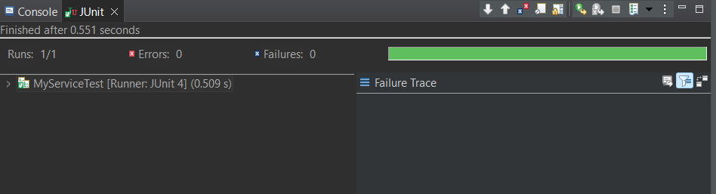

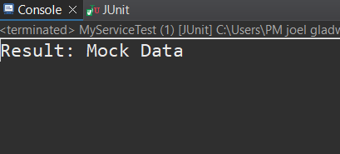

**Exercise 2: Verifying Interactions**

**CODE:**

import static org.junit.Assert.*assertEquals*;

import static org.mockito.Mockito.*;

import org.junit.Test;

public class MyServiceTest {

*@Test*

public void testFetchDataWithMockReturn() {

ExternalApi mockApi = *mock*(ExternalApi.class);

*when*(mockApi.getData()).thenReturn("Mock Data");

MyService service = new MyService(mockApi);

String result = service.fetchData();

*assertEquals*("Mock Data", result);

}

*@Test*

public void testVerifyInteraction() {

ExternalApi mockApi = *mock*(ExternalApi.class);

MyService service = new MyService(mockApi);

service.fetchData();

*verify*(mockApi).getData();

}

}

**OUTPUT:**

